Meteorite Observation and Recovery Project Guide

Install the Camera and Modem

Install the Camera

3G/4G Modem Installation

Install External Components

Mounting Structure or Stand

Login and Configuration

SSH Keys

Observatory Configuration

Configuring the camera time zone

Configuring the dfnstation.cfg file

Internet Connectivity

Checks and Tests

Capture control test

Connection to the Internet and VPN

Modem Function and Signal Strength

In the Field

Connecting Remotely

Web Interface

Data and Events

MORP 2.0 Website

This document highlights notes from various installations, outlining the general process I’ve taken in the past, and some points of consideration. Most of these notes come from my observations and from <https://wiki.dfn.net.au/index.php/Main_Page>. I’ve linked to the appropriate page on the Wiki in each section and encourage you to review both. A copy of this document is printed for in-field use.

In general, my approach for once a camera has arrived from DFN is the following:

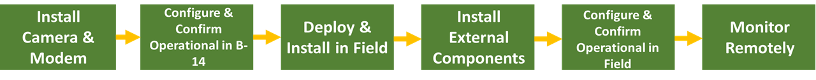

1. Install the camera and modem (if using). Typically I do this in ESB 1-60 as there’s lots of room to work.
2. Configure & Confirm Operational in B-14. Connect the observatory to the ethernet port in B-14, power it up, and work with [DFN Camera Help](mailto:dfn.camera.help@gmail.com) to make sure it is operating properly and you can access it via the terminal to configure it. I would do a dry run of configuring the observatory in B-14 before going into the field so that you’re prepared.
3. Install in the field. Whether you’re replacing a unit for maintenance or installing at a new site, you will need to create a FAP, rent a vehicle, and work with the individual at the site to access the area. For a new site, you’ll need to deploy and build a stand for the observatory. You can use the DFN Wiki page to get some ideas: [Physical Installations](https://wiki.dfn.net.au/index.php/Getting_Started#Physical_Installation) or you can look at our other setups in Alberta, which can be found in the Google Drive. Ultimately, this is a conversation you will need to have with the property owner and determine what they see as the best approach.
4. Install all the external components. With the observatory now in place in the field, you can install the sun shield, GNSS and mobile data antenna, and WIFI antenna.
5. Connect to the observatory via the terminal and configure it. You can perform multiple tests to ensure that the observatory is operational and connected to the internet before leaving the field. Assuming everything is working, you can leave the site and email DFN that it is set up and they should be able to see it. **Note: when you return to campus, update** [**Current Cameras Information**](https://docs.google.com/spreadsheets/u/1/d/1ZvNzDD16SxbxlFqp4P9-EW6SR6n75FH-W4f9ra4t1gM/edit) **changing the location of where the camera has been deployed.**
6. Monitor Remotely. Use the VPN to monitor the camera and the MORP data site to see the events captured.

While the cameras are in the field, you will need to work with [DFN Camera Help](mailto:dfn.camera.help@gmail.com) to make sure the camera is continually operating. I would recommend using the VPN (see the section below) to make sure the cameras are operational (checking every 2-4 weeks). When a camera goes down, the first step is to contact the local individual and ask them to restart the camera. Sometimes it helps to switch the system off for a few hours, or for a day if that was more convenient so email the individual at the site to unplug the camera and leave it for a bit. If there’s no response, then it’s likely going to require you to travel to the site and swap it with a functioning observatory. Generally, I take the camera I’m going to swap through the steps outlined above, but obviously as a stand has already been built the deployment portion is just swapping out the system. When you bring the camera back, then troubleshoot the camera in B-14 while it’s plugged into the ethernet port.

## Install the Camera and Modem

### Install the Camera

Once the sky camera arrives, assembly of the box and configuration of the camera should be done in the lab prior to entering the field. The steps for setting up the camera are the following:

* Plugin the power, USB, and shutter control cables into the camera before attachment. Then attach the camera body to the liquid crystal lens. This might need you to undo the screws holding the lens in place and reattach it later. Line up the dots and secure them into place. Note that the DFN wiki page has a good breakdown of these steps with images: [How to Install Lens](https://wiki.dfn.net.au/index.php/How_to_install_flanged_Samyang_lens_and_DSLR_to_the_DFNEXT_enclosure)
* Make sure everything is plugged into the control board on the left side of the main box. This DFN wiki page highlights the internal components of a DFNEXT observatory: [DFNEXT Summary](https://wiki.dfn.net.au/index.php/DFNEXT). Here’s an image of the inside of the box fully setup:

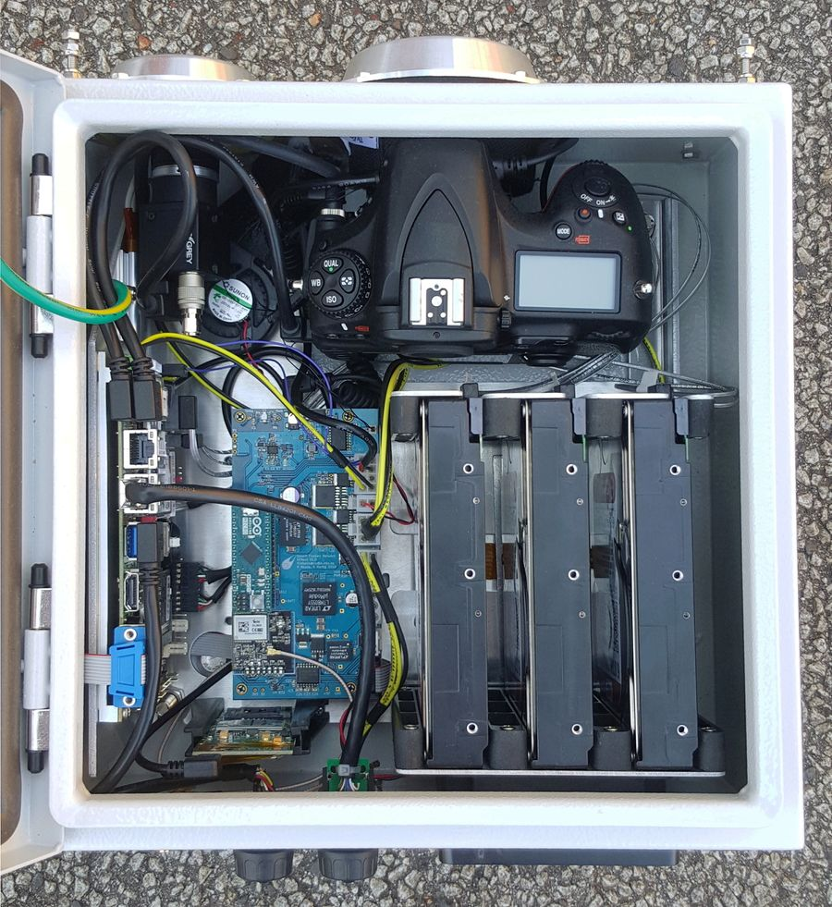

### 3G/4G Modem Installation

This only applies to cameras you want to connect to the internet using a data plan; we currently have two cameras that use data (Granum and Mattheis Ranch). To request a new SIM card, I contacted the Communications Coordinator in the Earth and Atmospheric Science department and they were able to order two SIM cards with Telus. Here is a link to the [University's Telus Plans](https://uofaprod.service-now.com/kb_find.do?sysparm_search=cell%20phone%20plans). If you need to contact anyone about the plan or SIM cards status, you can reach out to IST ([ist@ualberta.ca](mailto:ist@ualberta.ca)). You may also want to check the Telus coverage in the proposed site: [Telus Coverage Map](https://www.telus.com/en/bc/mobility/network/coverage-map).

In addition to acquiring the card, you will need to purchase a modem. The modem used is Sierra Wireless AirPrime MC Series 7455, and I contacted Igor Jakab in the department to help me purchase one. Finally, you need to request a modem installation care package from [DFN Camera Help](mailto:dfn.camera.help@gmail.com) before you can install everything (we do have some in storage). I would be sure to communicate with DFN early on that you plan on installing a SIM and modem as they will need to get that for you. Currently, they send out a [Blue PCB Board](https://wiki.dfn.net.au/index.php/DFNEXT_Modem_Installation) as part of the installation but earlier on they used to send out a [Green PCB board](https://wiki.dfn.net.au/index.php/DFN_Modem_Installation_-_Green_card) and we do have some installed (e.g., DFNEXT 022). Make sure you’re familiar with both installations for maintenance (I’ve printed both for use in the field).

To install, the installation care package, modem, and SIM card, follow the instructions on the DFN wiki: [Blue PCB Board](https://wiki.dfn.net.au/index.php/DFNEXT_Modem_Installation) and [Green PCB board](https://wiki.dfn.net.au/index.php/DFN_Modem_Installation_-_Green_card). I’ve noticed that the USB pinhead that DFN sends doesn’t match those pictured in the installation guide for the Blue PCB Board. Make sure that Port 1 on USB pinhead is in either Pin 1 or Pin 2 which have a 5VSB signal (see the [Manual](http://www.commell.com.tw/Download/Manual/LE-37G_Manual_V22.pdf) for the computer board on page 19 for CN_USB1).

Once you have installed the system, you then need to configure the mobile network. To do this in the past, I have plugged the camera into the B-14 ethernet port and DFN Camera Help has then made sure everything works as I’m not overly comfortable with coding. However, the information to do it yourself can be found here: [Mobile Network Configuration](https://wiki.dfn.net.au/index.php/Mobile_network_configuration). When you’ve powered on the observatory there are several checks you can perform to check the signal strength and ensure the observatory is connected to the internet. These are highlighted in the appropriate section below.

**Note:** If you want to test the 3G/4G connectivity at the University of Alberta before you install the observatory in the field, you have to remove the box from B-14. The signal isn’t good enough so I take it to ESB 1-60 and plug it in by the window. You can also install the GSM antenna to boost the signal.

### Install External Components

When you deploy the camera in the field, you will need to install the 3D printed air duct, sun shield, GNSS and mobile data antenna, and WIFI antenna. Their location on a camera in the field can be seen in the image below. Note that the 3D printed air duct is usually held in place by UV resistant silicone and most of the observatories in our possession have them already installed. If you are doing maintenance on an observatory that has been out in the elements for a while, it may need a touch-up of glue. If possible I would glue the air duct on campus before deployment. When you install the system in the field, we place a small nut on top of the 3D printed air duct so that when the sun shield is put in place and tightened it also secures the air duct without being in direct contact with it (see image below).

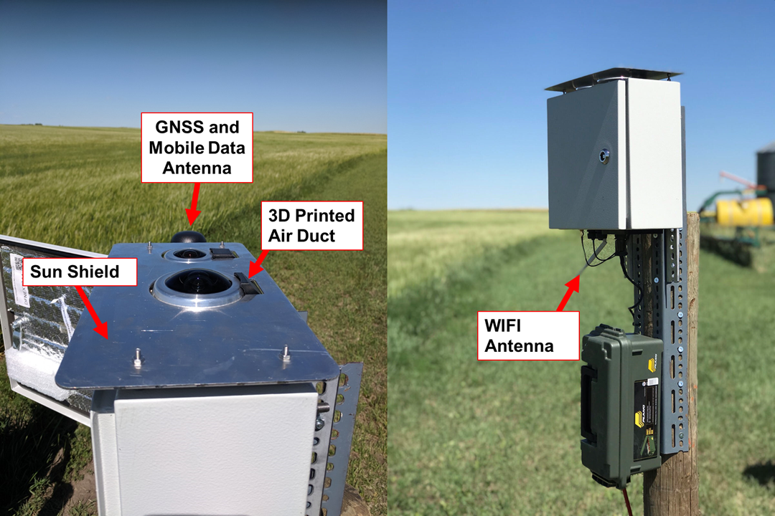

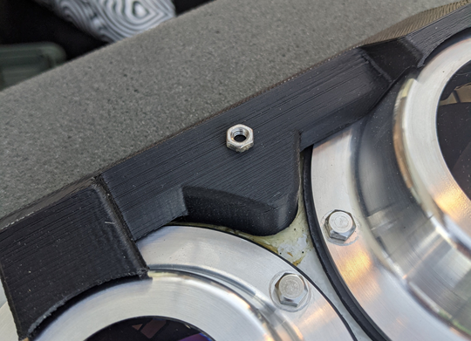

### Mounting Structure or Stand

As mentioned, for a new site you’ll need to deploy and build a stand for the observatory. You can use the DFN Wiki page to get some ideas: [Physical Installations](https://wiki.dfn.net.au/index.php/Getting_Started#Physical_Installation) or you can look at our other setups in Alberta, which can be found in the Google Drive. We currently don’t have a go to method for a stand and each site installation has depended on the individual site and consultation with the host. Here I have outlined some important notes about the stand and factors that need to be considered in the deployment such as tools required, orientation, mechanical interference, and power.

**Tools Required**

The camera has 4 main mounting bolts on the back and a sunshield on the top. I have added to the list provided by the [DFN Wiki - Toolkit](https://wiki.dfn.net.au/index.php/Camera_Maintenance_Toolkit).

* 13 mm wrench
* 7 mm wrench
* 7 mm socket (in case you need to reinstall the camera lens)
* 8 mm wrench
* Adjustable wrench
* #0 Phillips screwdriver
* #1 Phillips screwdriver
* #2 Phillips screwdriver
* 1.4-2.4 mm flat head screwdriver
* Molex pin removal tool (I’ve never actually used this)
* Camera enclosure key
* Ethernet cable
* Extension Cord
* UV resistant silicone (for air duct)
* UV resistant cable ties
* Brush for cleaning
* Broom and dustpan for cleaning
* Sun shade and chair (for comfort while working)

To transport the observatories into the field there are two options. You can use the boxes they were shipped in (I’ve kept all the boxes from the last shipment and foam). Alternatively, Peter Carlson (a former field technician with the department) made pelican cases that can be used to carry the observatories. Both work well to cushion the observatories and prevent excessive movement. Regarding where to find the tools for the field, I have several tools kept in the cabinets; however, most tools will have to be borrowed from the department based on what’s available in 1-60. For the spanners, Chris has some metric wrench in B-14 next to gas cylinders. I use them and return them there when I’m done with them.

**Orientation and Field of View**

The camera box door should face north as close as possible. This is not essential and the orientation doesn’t have to be precise but do try to ensure it is looking northward. The camera does see the whole sky; however, there are 2 “blind spots” which are 10° above the horizon in the north and south direction (assuming the door is pointed north). As a result, there are two points to consider:

1. Are there other cameras in the network directly north or south that you want to maximize overlap with?
2. Are there obstacles on the horizon or in the field of view east and west?

Point 2 is more important and if it is the case that there are objects to the east and west, you can rotate the observatory so that these objects are in the “blind spots”. The software can cope with not being exactly north-south aligned; however, I do let [DFN Camera Help](mailto:dfn.camera.help@gmail.com) know if this is the case post-installation.

**Mechanical Interference**

The rigidity of the stand is very important, especially if you are installing it in a windy location. The camera takes images with a 30-second exposure so vibrations of the camera in that time will blur the image. Therefore the heavier and stronger the stand the better! Except for Mattheis Ranch and Granum, most of the stands have required a rooftop stand. This usually requires making a flat base platform that has a right-angle triangle frame at 90° to ensure a stable structure. Examples from the DFN Wiki are provided below.

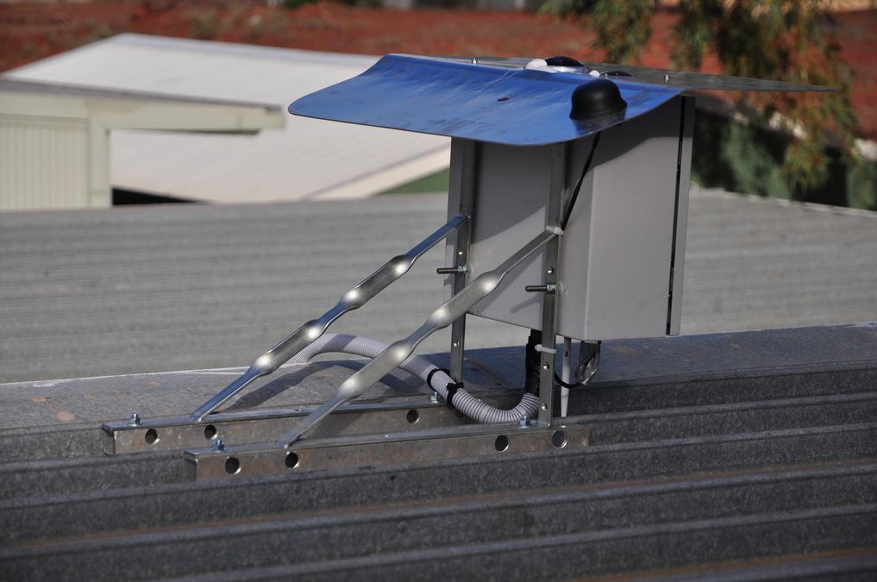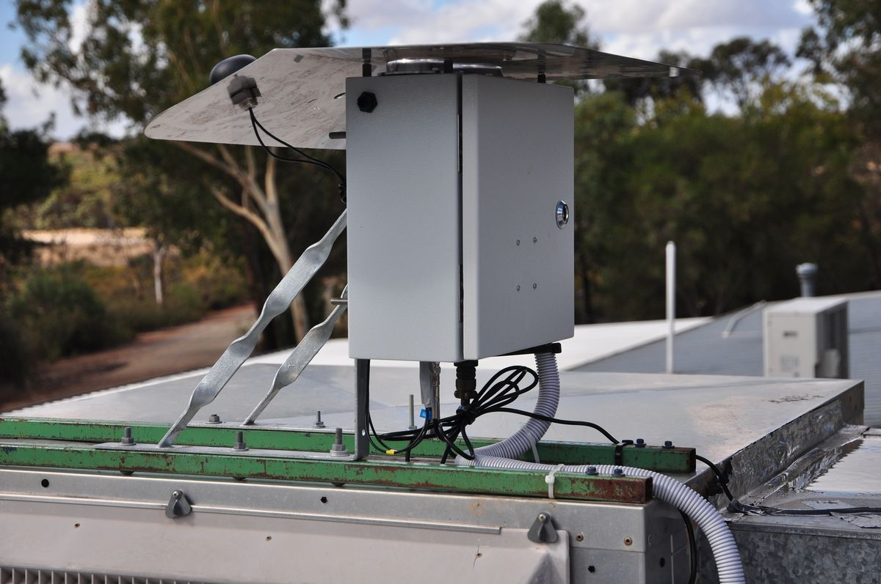

**Power**

The power connector is a 4 pin, green, metal Amphenol connector which is located on the bottom of the observatory box. If the system is mains powered, the 12 V power adapter (which is provided with the observatory) is an indoor unit and should therefore be placed in an outdoor, weather proof container. To date we have used green boxes provided by the department (located in the cupboards in 1-60); however, something like [SOCKiTBOX | Weatherproof powercord connection box](http://www.sockitbox.com/) would be better suited. The power adaptor needs an IEC cable to connect to a main socket. We have several extras in 1-60.

## Login and Configuration

While you’re ensuring you can log in and configure the camera, I highly recommend plugging the ethernet cable into the box and connecting it to the port behind the computer closest to the ovens in B-14 (port C030 works well). This way if you have any issues logging in, installing your SSH key, or require additional assistance in general, [DFN Camera Help](mailto:dfn.camera.help@gmail.com) can see the camera and help. While it’s connected via the ethernet cable, for the rest of the configuration, I recommend connecting and working using the WiFi and terminal.

Now that the camera is physically powered on we can now log in and configure the camera. All DFNEXT systems have WiFi connectivity out of the box. The observatory acts as a WiFi access point (this is called AP mode); to connect, just select the relevant WiFi network SSID from your observatory (e.g. DFNEXT013 is the SSID of the WiFi network to connect to the observatory with hostname DFNEXT013; WiFi network name is the camera system name, eg DFNEXT013, password 'MeteoR123'). Note: it takes ~1 minute for the WiFi network to appear.

**Troubleshooting: I can’t see the observatory as a WiFi network**

This is a common error that I have encountered and fortunately has an easy fix. Usually, this is the result of a power issue. To check this you’ll need to grab the voltmeter from ESB 1-60. You’ll want to confirm that the black and yellow wires in the green screw terminal on the PC board are properly and fully inserted (see picture below). **SAFETY: be sure to do this when the observatory is unplugged as these are live wires**.Once you confirm that the cables are fully installed, use the voltmeter to check that the PC is powered. It should read ~ 12V on the screws of the terminal block. If this doesn’t resolve the issue and you’re reading 12V but it’s not an available WiFi network, contact [dfn.camera.help@gmail.com](mailto:dfn.camera.help@gmail.com).

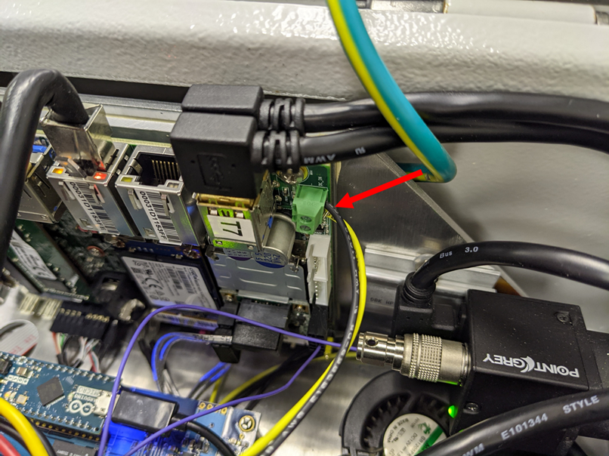

To log in to the system, you will need to utilize a terminal. For Mac you can just use the terminal app; however, for a PC you will need a Linux subsystem to log in. On Windows 10 I’ve used the [Microsoft Windows Subsystem for Linux](https://docs.microsoft.com/en-us/windows/wsl/about) without any issues and simply followed the instructions they provided for installing WSL. The DFN Wiki does have a section on logging in via the terminal using the Windows system, and I recommend following those instructions: [Logging in via WiFi or Ethernet](https://wiki.dfn.net.au/index.php/Logging_in_locally_via_WiFi_or_Ethernet).

Once you open the terminal, you need to use the IP address to connect. The IP address of the observatory is 172.16.0.101; to connect run the following command in the terminal:

***ssh root@172.16.0.101***

The camera will then prompt you for its root password or your SSH key. For security reasons, they changed it so that you can’t use the root password (string of numbers and letters in the box) to log in as root user anymore so you have to log in as dfn-user then switch to the root user.

**Logging in as dfn-user**

For security reasons, password-based authentication is disabled for the root user by default in the latest (DFNEXT) observatories. If you want to log in using the password on the box, you will need to log in to the “dfn-user” and then change to the root user. The password for the dfn-user is that string of numbers and letters listed in the box. If the observatory doesn’t have that string, then contact [DFN Camera Help](mailto:dfn.camera.help@gmail.com). Some of the older observatories like DFNEXT022 were set up before the randomly generated passwords. In that case, the password is: “Alberta022.”

To log in, simply type the following in the terminal:

***ssh dfn-user@172.16.0.101***

Enter the password and then switch to the root using the command:

***su -***

It is easier if you add the IP to your SSH keychain so that you will automatically be logged in via your SSH key. (SSH keys are a more secure, faster and more convenient alternative to passwords for logging into computers over the network).

### SSH Keys

SSH is a secure way of logging into a terminal session on a remote computer. SSH keys are a way of authenticating with an SSH server that can be used instead of passwords. They are faster and more convenient than password-based authentication and can be more secure. They are the recommended authentication method to use when logging into DFN observatories. Note it is not required for the setup of the camera; however, it saves entering in the long password that comes with the camera every time. The two biggest advantages of keys over passwords are:

1. You can unlock your personal key once (per local session) and then log into as many different ssh-servers (cameras in this case) as you want without having to enter your password again using an ssh-agent;

2. You can then disable password-based login to protect against brute force dictionary attacks.

Once you have one, SSH keys are much faster and easier to use than passwords but creating one can be a bit daunting. The DFN Wiki page on SSH keys is [here](https://wiki.dfn.net.au/index.php/SSH_Keys).

The SSH key that you create will consist of two parts: a public key and a private key. The private key is your authentication or identity document and you must keep it secure. This is done by password protecting it when you create it and also restricting access to the file (you shouldn't give your private key to other people). The public key is used to check that the person logging in possesses the private key.

First, check to see if you have any ssh keys already by running in the terminal the following command:

***ls ~/.ssh/id_\****

If the directory doesn't exist, or no matching files are found, then you do not have an existing key and you can proceed.

If you do have an existing key, and it is password-protected, you may want to use it **(skip to Installing your SSH key),** or you may want to generate a new key just for your observatories alongside your old key (in this case please backup your existing and adapt the below instructions to avoid overwriting your existing key).

Create your SSH key with the following command (substituting your email address for your_email@address.com or some other identifying information such as name@institution):

***ssh-keygen -t rsa -C your_email@address.com***

After running this command you will be prompted for the key location. Press enter to accept the default location for saving the key. ssh-keygen will now prompt you to enter a password. **It is very important that you enter a password at this stage.**

Press enter once you have entered your password and you will be prompted to confirm your password by entering it again (press enter again afterward). Your key has now been generated and is ready to install.

The private key is now located at ~/.ssh/id_rsa and your public key is at ~/.ssh/id_rsa.pub. At this stage, you probably want to back both of these files up in a safe and secure place (although the public key can be regenerated later from the private key if required) and also note where the files are saved in your computer for future access.

Now it is time to install your SSH key onto the computer or DFN observatory that you want to log in to. If you have access to the system you would like to install your key on, this is easily accomplished with the ssh-copy-id command. This command will connect to an SSH server, prompt you for the password and then install your public key for you. You need to know the username that you want to log into (probably root if you're configuring or doing maintenance on a DFN observatory), the user's password, and the IP address of the observatory or computer.

As an example, to install your key into a **DFNEXT** for the root user you would run the following command:

***ssh-copy-id root@172.16.0.101***

After running this command, you will be prompted for the remote user's password (for example the root user's password on the box). Enter the password and press enter. Your key should now be installed.

You can also manually install your key. While logged in as the root user, simply run:

***nano /root/.ssh/authorized_keys***

Then copy and paste your public key to this file and then exit and save changes. **Note: Always add your key at the end of the authorized_keys file. Make sure you will not overwrite/remove/mis-edit the existing keys there!**

You can test this by SSHing into the remote system, you should be prompted for the password of your key instead of the long password of the remote user on the box. Run:

***ssh root@172.16.0.101***

You can simply use your passphrase instead of logging as dfn-user and the password within the box and then switching.

That was the process for adding the key when you are connected via WiFi (AP mode) as described above. You can do this via ethernet conductivity as well and I would suggest you follow the desert cam wiki for more information. If you have difficulties installing your SSH key on an observatory, you can also give your public SSH key to [DFN Camera Help](mailto:dfn.camera.help@gmail.com). He can then install it for you so long as the camera is connected to the internet (usually an ethernet connection). Once you generate your public SSH key, I would recommend sending it to [DFN Camera Help](mailto:dfn.camera.help@gmail.com) anyways via email as he can install it on all the observatories in the field, making it easier for when you get to the site.

### Observatory Configuration

Now that you can log in via the terminal you can configure the observatory. There are two main settings you must configure before using your camera:

* Location and name of the station site
* Camera time zone

These will mainly have to be done in the field when the exact location of the camera is known (longitude and latitude from a GPS measurement). However, opening the configuration and setting the time zone in the lab is good practice before going into the field. Also, do an interval control test within the lab to make sure everything is functioning before deployment.

#### **Configuring the camera time zone**

Log in using the root, set the timezone using the command:

***dpkg-reconfigure tzdata***

Edmonton is on the list of cities so simply select that.

#### **Configuring the dfnstation.cfg file**

The file /opt/dfn-software/dfnstation.cfg is the main configuration file for the camera operations and software. You need to configure some settings in this, to set the camera location and name, so that the camera still has sensible values in case the GPS system has a problem.

Log in using the root and then run **nano** a built-in editor in the terminal. To edit the file, run the following command:

***nano /opt/dfn-software/dfnstation.cfg***

You only need to edit the section under **[station]**; however, this does list all the camera settings in case you are interested. These are the following lines you’ll need to edit (the Eiffel Tower is given as an example):

***[station]***

***lat = 48.8580***

***lon = 2.2938***

***altitude = 354.0***

***location = Eiffel_Tower***

These fields will be edited during development in the field, but if you’re in the lab make sure you can locate the section at this stage. For the deployment, remember the following:

* Use a handheld GPS unit or a GPS app on your phone, and get the local GPS coordinates for latitude, longitude, and elevation. This should be in decimal degrees, with a datum of WGS84, elevation is in meters. Use negative latitude numbers for the southern and western hemispheres. **Don't forget the camera might be some meters above the ground where you are holding the GPS unit.**
* The camera also needs a location name, which is a descriptive location. **Do not have the string "test" in the name, or the central server will ignore data from this camera!** (Unless you want the server to ignore the camera, for example, if you are repairing it and it is indoors).
* Also, don't use spaces in the location; i.e. use "New_york". Capitals or lowercase doesn't matter.

When you make the changes in the field, simply follow the commands at the bottom to exit and ensure that you save the file when prompted.

### Internet Connectivity

All of the cameras that I have worked with have either been connected to the internet via ethernet cable or 3G/4G using a modem. To set up an internet connection via ethernet in the past, we’ve just plugged in the ethernet cable to the observatory and the other end to the network connection. All DFN observatories have two Ethernet ports. One is used to connect the camera to the internet if there is wired internet available. This port is labelled Network/eth1 on the DFNEXT observatories. The other port is used for logging into the camera with your computer. This port is labelled Laptop/eth0 on the DFNEXT observatory.

For the 3G/4G modems, I’ve always let DFN Camera Help set up the connection. I just plug the observatory into the B-14 ethernet port and DFN Camera Help has then made sure everything works as I’m not overly comfortable with coding. However, the information to do it yourself can be found [here](https://wiki.dfn.net.au/index.php/Mobile_network_configuration).

For internet connection over WiFi, I’ve never had to set up this connection so I recommend you communicate with DFN Camera Help on how to do this. The DFN wiki page on the connection can be found [here](https://wiki.dfn.net.au/index.php/WiFi_configuration).

## Checks and Tests

Once you’ve configured the camera, you’ll want to check everything is functioning. Specifically, you want to make sure it is connected to the internet, the camera is working, and the VPN is working. This section breaks down those tests and some minor troubleshooting. If your solution isn’t resolved be sure to contact [dfn.camera.help@gmail.com](mailto:dfn.camera.help@gmail.com). Once again before deploying an observatory in the field, where possible, I would highly recommend you do these tests in the lab so that you know the observatory is functioning properly before deployment.

### Capture control test

Login using the root and run a capture control test using:

***/opt/dfn-software/interval_control_test.sh***

This will take about 10 minutes and simulate a night’s worth of observations in a short period of time. It will wait for 2 minutes until "sunset", take photos for about 5 minutes, until "sunrise", and then stop, and download the images.

**Note:** if the DSLR memory card is full or has a lot of images, this test will take a long time, as it will first download all the existing data from the DSLR. This shouldn’t happen as the camera is new.

After the test is finished, check images using:

***ls /data0/latest_prev*** (ensure there are a few .NEF image files – usually five). We also recommend checking the interval log (e.g., 2018-01-17_DFNEXT013_log_interval.txt) for any errors or warnings.

**Note:** /data0/latest_prev is a symbolic link to a specific (previous) capture session directory, e.g., /data0/DFNEXT013/2018/01/2018-01-15_DFNEXT013_1516021913. During the capture control test run (or regular capture program run during the night), it's /data0/latest that links to the current directory.

If you are able, it’s also good to do an overnight test and download several of the files from last night. To do this, log in as root and enter the following:

***ls /data0/latest***

You can also count the raw image files using:

***ls*** -***1 /data0/latest/*.NEF | wc -l.***

### Connection to the Internet and VPN

To check the connection to the internet and VPN using the terminal simply use the command:

***ping google.com***

This will ping Google and you should see a response. To stop pinging, use CTRL + C. Similarly to check the connection to the VPN, use the command:

***ping 10.1.16.1***

This will check the connection and check the VPN. The VPN is what will enable you to monitor the camera remotely using the web interface. I’ve highlighted how to set up and use the VPN in the Web Interface section.

**Note:** You can also check the connectivity in the Web GUI (see later section). There is a function called "Check Internet" and "Check VPN”.

### Modem Function and Signal Strength

To check a modem with the SIM card installed is functioning, you can run the aforementioned internet connection test and VPN test. If the card and modem are working properly, you will be able to connect to the internet. In addition, you can confirm the strength of the signal by running the following command:

***dfn_print_mobile_signal_quality.sh***

The DFN wiki provides a page on [Signal Strength](https://wiki.dfn.net.au/index.php/Mobile_signal_strength_check). In case of no signal, check the LED indicator on the modem adapter board(s). The blue PCB board has a blue light, the green one should too. If there is no light, it is not correctly connected to the PC with the USB cable or the modem module is incorrectly connected or is not working. Also, the modem signal check would say:

Detecting modem type...

Error: no supported Sierra Wireless modem found.

**Note:** this is what the terminal will produce if you don’t have a modem installed if you would like to try in B-14.

If the lights are on and it’s not complaining about modem missing, but still no signal: check HF cables (the pigtail patch cable inside and the external antenna cable). Also, make sure GPS/GSM antenna is connected correctly (the antenna is dual with two connectors of the same type).

When you run the signal quality command, you will get a lot of information. Here is an example from one of the Australian 4G connected sites with somewhat marginal signal quality. This one is actually often offline because of too low of a signal. You should get something similar, just with a different band and operator (Telus not Telstra), and of course, the signal levels should be better.

Detecting modem type...

Bus 001 Device 002: ID 1199:9071 Sierra Wireless, Inc.

Checking signal reception quality for modem MC7430/MC7455 at port /dev/ttyUSB2.

ATI

Manufacturer: Sierra Wireless, Incorporated

Model: MC7430

Revision: SWI9X30C_02.24.05.06 r7040 CARMD-EV-FRMWR2 2017/05/19 06:23:09

MEID: 35907406055848

IMEI: 359074060558485

IMEI SV: 12

FSN: LU806512990210

+GCAP: +CGSM

OK

AT!gstatus?

!GSTATUS:

Current Time: 1367778 Temperature: 28

Reset Counter: 1 Mode: ONLINE

System mode: LTE PS state: Attached

LTE band: B28 LTE bw: 20 MHz

LTE Rx chan: 9410 LTE Tx chan: 27410

LTE CA state: NOT ASSIGNED

EMM state: Registered Normal Service

RRC state: RRC Connected

IMS reg state: No Srv

PCC RxM RSSI: -95 RSRP (dBm): -125

PCC RxD RSSI: -97 RSRP (dBm): -140

Tx Power: 0 TAC: A09D (41117)

RSRQ (dB): -11.3 Cell ID: 08E0FD00 (148962560)

SINR (dB): 1.6

OK

AT+COPS?

+COPS: 0,0,"Telstra Mobile Telstra",7

OK

AT+CSQ

+CSQ: 11,99

OK

Checking signal reception quality for modem MC7430/MC7455 using Qualcom protocol.

[/dev/cdc-wdm0] Successfully got signal info

LTE:

RSSI: '-92 dBm'

RSRQ: '-12 dB'

RSRP: '-125 dBm'

SNR: '2.0 dB'

**Note:** You can also check the signal in the Web GUI (see later section). There is a function called "Check Modem Signal”.

## In the Field

Once the camera has been physically mounted, it is time to set up the camera. Make sure to do the following:

* Install all the external components as previously described.
* Configure the dfnstation.cfg file and time zone.
* Perform all tests to ensure functionality.

Once you’ve done all that you can pack up and head out. Once I get internet access, I usually email [dfn.camera.help@gmail.com](mailto:dfn.camera.help@gmail.com) to make sure everything is okay on their end.

## Connecting Remotely

## Web Interface

In addition to connecting to the observatory via the terminal, once it’s operational, you can connect via the [web interface](https://wiki.dfn.net.au/index.php/Web_Interface). This is a more user-friendly interface that allows you to see the status of the camera and do certain operations.

To log into the web interface, launch a web browser on your local computer or mobile device and enter the IP address of the camera as well as the web interface port (8080).

**If you are connected via Ethernet (Laptop/eth0 port)–**

The IP address of the observatory is 172.16.1.101, so you would enter 172.16.1.101:8080 in your browser's address bar.

**If you are connected via WiFi (observatory in AP mode)–**

The IP address of the observatory is 172.16.0.101, so you would enter 172.16.0.101:8080 in your browser's address bar.

For a camera in the field, you need to:

-connect to the VPN. Note that you may need to download an OpenVPN for Windows or Mac.

-each user has their own VPN provided to them by the DFN. Note that the VPN installer may be encrypted so you will need a password from the DFN. No password is necessary for the actual VPN.

-once successfully connected to the VPN, each camera has a unique IP address. In the case of DFNEXT036 (for example) the URL would be [http://10.1.23.36:8080](http://10.1.23.36:8080/) where the 36 would change depending on the number of the camera you are trying to access.

It also works over the GFO VPN. To set up the VPN on your laptop, you will need to make sure that you have a functioning connection to the VPN. The DFN Wiki page describes how to set this up in detail. I was able to easily set it up on my PC using OpenVPN: [DFN Wiki Page: Logging in Remotely](https://wiki.dfn.net.au/index.php/Logging_in_remotely_over_the_network). You will need to request a VPN certificate from [DFN camera help](https://wiki.dfn.net.au/index.php/Getting_Help) but once you have that you can use OpenVPN to connect to the web interface remotely from campus.

Once you’ve connected via the VPN, you can connect using any browser. Note that each camera has a unique IP address. In the case of DFNEXT036 (for example) the URL would be http://10.1.23.**36**:8080 where the 36 would change depending on the number of the camera you are trying to access. The DFNEXT0## number for each camera location can be found in the [Current Cameras Information](https://docs.google.com/spreadsheets/u/1/d/1ZvNzDD16SxbxlFqp4P9-EW6SR6n75FH-W4f9ra4t1gM/edit) spreadsheet.

Note that your computer will be slower when it is connected to the VPN and that clicking links may not work until you disconnect. If you need to follow a link on this document or elsewhere, it is better to copy and paste the links onto your browser's search bar.

**NOTE:** be careful here please, make sure you are connecting to the correct system number, others could be in other parts of the world!

More details on the GUI functionality are [here](https://wiki.dfn.net.au/index.php/Using_the_GUI_for_Regular_Maintenance).

You should then see a dark red, orange, and black web interface asking for login information.

You will need to enter the username and password before pressing Login. The default username and passwords are "dfn" and "fireBALL123". This should connect you to a window like the following where you can do remote tests and checks.

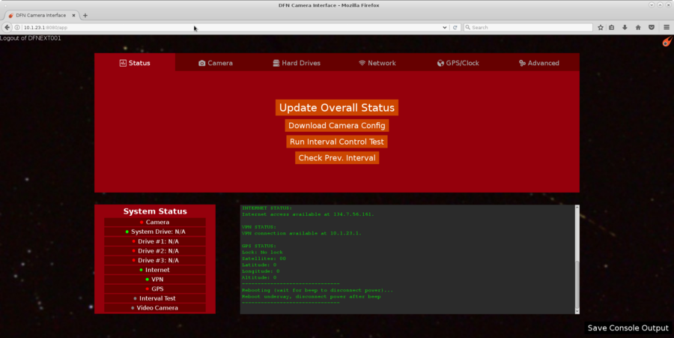

**Connecting to an Observatory with the Terminal over VPN**

You can also connect to any of the observatories via the terminal with the VPN. With the VPN connected, simply enter:

***ssh root@10.1.23.##***

**NOTE:** the ## is replaced with the camera you are trying to connect to. For example, if you wanted to connect to DFNEXT052, you would enter: ssh root@10.1.23.52

You can now use the terminal as if you were connected via WiFi.

## Data and Events

**Manually Downloading Images**

In the event that there is a potential fireball event or you just want to download an image from a specific location you can download the images from the camera using the Web Interface, WinSCP (for Windows), or sftp/scp in the Linux or Mac OS environment. (I have only used windows so I’ve described that process below).

To download images via the web interface simply log into the camera you want to access (as described above) and go to the camera tab. You notice that there is a “Download Pictures” interface where you can simply select the date and local time and download the image. I would recommend just downloading the .jpg as the .NEF file is the raw product and is very large.

In its idle state, you can only download images from the past two days. This is because those images are saved in the /data0 drive within the system drive, which is always turned on, whereas older images are stored in Drive #1, Drive #2, or Drive #3, which are turned off in the idle state. To access those you must first turn on and mount the drives:

* Go to the “Hard Drives” tab and select “Power On Drives” (a message saying this may take ~20 seconds will pop up).
* Once the drives are powered on, select “Mount Drives”

You should notice that the red icon next to Drive #1, Drive #2, and Drive #3 should turn orange when powered on and then green when mounted. **Note: you must unmount and then power off the drives when you are finished downloading images. Do not leave them mounted or powered during the night. Simply click the “Unmount Drives” then “Power Off Drives” when you are finished downloading.** Once mounted, you can now access the older dates in the “Camera Tab”.

The aforementioned method is great if you know the specific time that event occurred; however, if you want to know if the camera detected a potential fireball, the best way is to check using WinSCP. Here is the link explaining using WinSCP on the DFN wiki: [Mswin winscp - DFN Wiki](https://wiki.dfn.net.au/index.php/Mswin_winscp) and PDF explaining how to download using WinSCP: [PDF WinSCP Connection to Camera](https://wiki.dfn.net.au/images/a/a8/WinSCP_connection_to_camera.pdf).

To use WinSCP with VPN, you need to start a new session by going to “Session” → “New Session”. You’ll want to create a new session (name it camera or dfn for future use). Then add the following settings so it matches the screenshot below. **Note: similar to accessing the web interface or over the terminal, the last two digits in the hostname are the camera number. In the example below, it would connect to DFNEXT021.** I usually just edit the same login and change the last two digits depending on which camera I want to access.

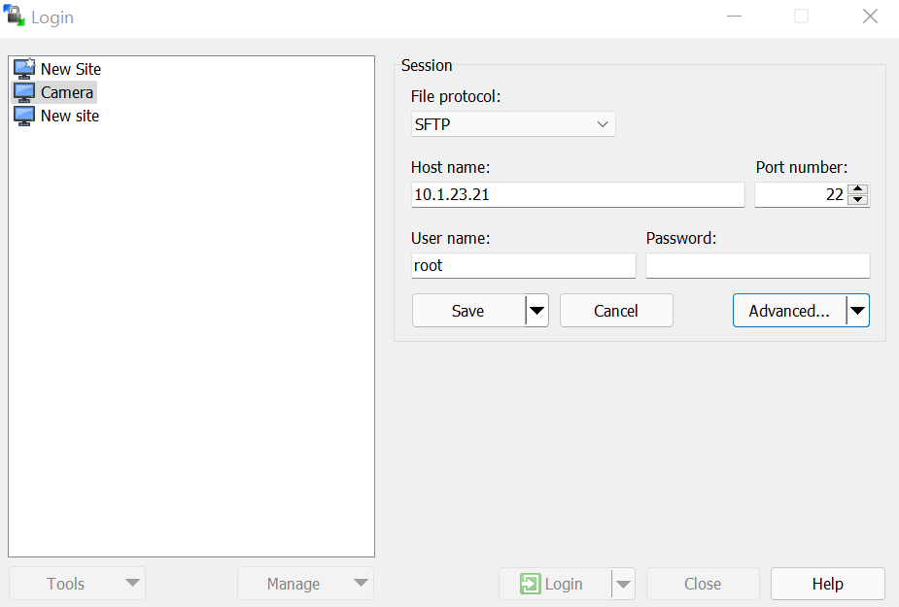

Before you log in, you have to connect to your ssh private key. To do this click “Advanced…”, in the window that comes up go to “SSH---Authentication”. Under “Authentication parameters” you need to select the location of your private key (wherever you saved it in your computer after you made it). See below:

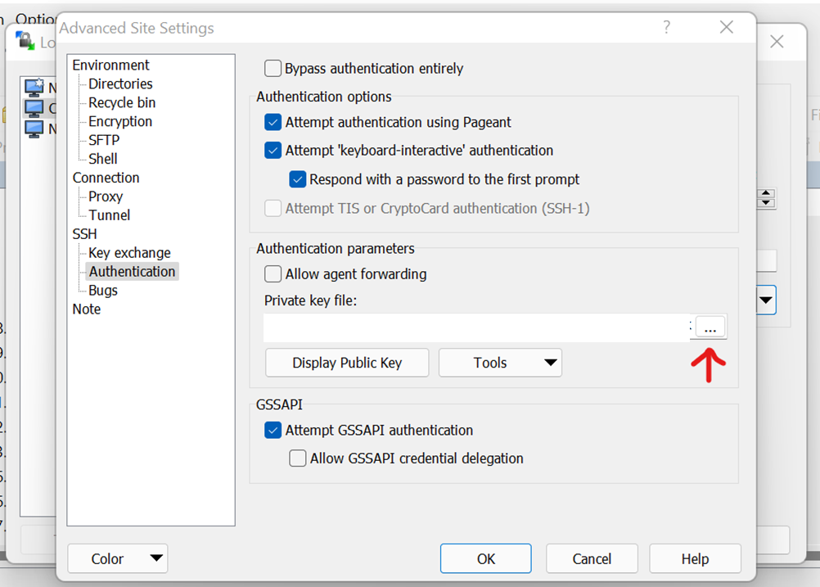

Once you’ve done that, while connected to the VPN, you can click “login” and it will prompt you for your SSH key password. The [PDF WinSCP Connection to Camera](https://wiki.dfn.net.au/images/a/a8/WinSCP_connection_to_camera.pdf) provides a good guide for accessing data and the DFN Wiki has a good page on [DFN observatory data folders and files structure](https://wiki.dfn.net.au/index.php/DFN_observatory_data_folders_and_files_structure). **Remember you have to have harddrives powered on and mounted if you want to see /data1, /data2, or /data3 (in other words if you want to access older folders/images).** The important thing to note is that each night has its own folder with the naming convention:

2018-01-30_DFNEXT022_1517353916 ... YYYY-MM-DD _ observatory name _ UNIX epoch time at the time when folder was created (So click the folder with the date you want to look at).

Each of these folders contains up to over 1000 captured still images and a few other files like text logs. (The number of images depends on the duration of night and cloudiness.) The files (still images) have time-based file names as well, see the example:

022_2018-01-31_143200_E_DSC_1644.NEF ... NNN_YYYY-MM-DD_HHMMSS_T_DSC_XXXX.NEF

Where,

NNN1 is observatory serial number (DFNEXT022 in this case)

YYYY-MM-DD_HHMMSS is UTC time of the beginning of the exposure

T is the camera type (missing or S: DFNSMALL, E: DFNEXT, K: DFNKIT)

DSC_XXXX.NEF is the original file name from the Nikon DSLR

This means that if you want an image from a specific time, you need to know the UTC time. This means for example, that if you want the image from November 23, 2021, at 21:05 Mountain Time, your file name would 0##_2021-11-24_040500… This is because UTC time is ahead of Mountain Time (be sure to consider Daylight Savings Time when you’re near the time change).

A good thing to note is that if the software detects a potential event it changes the name slightly. Here’s an example:

078_2021-09-27_035958_E_DSC_0241.thumb.1200.400.tile.jpg

So you can look for the .thumb.1200.400.tile.jpg to see if it picked anything. In the situation that someone says they saw an event at a certain time, you can simply convert the time to UTC then go see if any files around that time have the “...thumb.1200.400.tile.jpg” ending. **Note: just because it has that ending doesn’t mean it has seen a fireball, it just means there’s been a change in lighting that could be a fireball so for example, it could be an insect or a bird flying across the camera or a sudden flash of light from a car or artificial source.** Once you find the image you want, you can right-click and download the image to a folder on your local computer.

If you need any help, you can always contact [DFN Camera Help.](mailto:dfn.camera.help@gmail.com)

### MORP 2.0 Website

The DFN has a private website that we can use to access data regarding fireball events caught by the network. It’s a very user-friendly website so I recommend you explore it on your own to see all its features. The URL to the site is [https://privatedata.morp2.gfo.rocks](https://privatedata.morp2.gfo.rocks/). The login details are:

username: morp-user

password: Photometric_component_image_vector_0

Once you log in, you should see a page like the following:

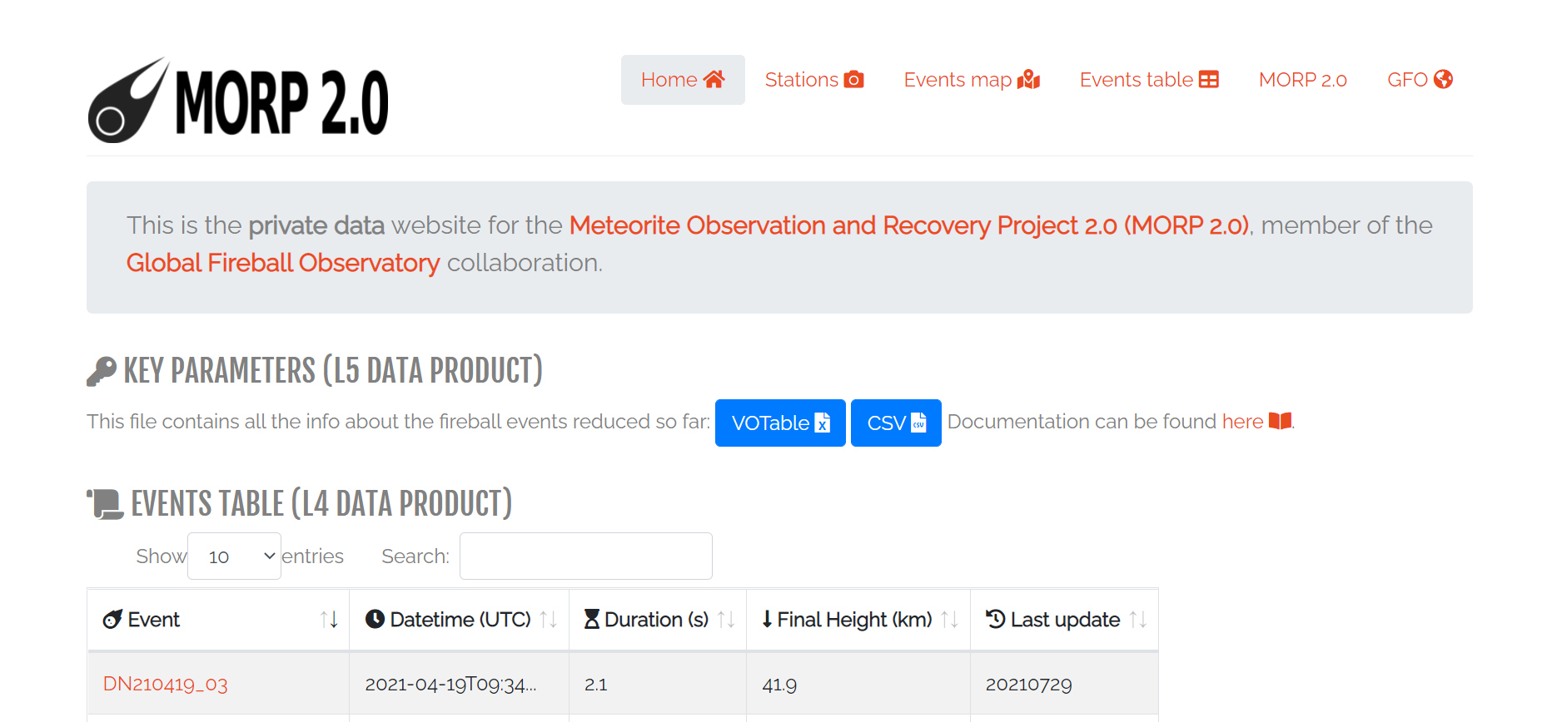

Unfortunately, there is currently no notification option for the website; however, DFN will let you know via email if your cameras have caught a promising event.

As you can there are lots of events but how do we know which events are likely to have produced meteorites?

Short answer: it's complicated. Calculating the surviving mass or even just knowing if there is one is still an active research area and there are various models that DFN uses.

Generally, however, the end height observed gives an idea (you can sort the table based on this criterion). A very basic rule of thumb:

* at ~30km end height, you *may* have a small meteorite.
* at ~20km end height, you are almost guaranteed to have a meteorite, and it's likely to be big (kilo-size).

In addition, two of the on-site managers requested access to the data and so they have their own accounts. Their login information is:

username: granum

password: crystal_chondrites_considering_seconds

username: vermillion

password: hours_coverage_dynamical_observatories

We can give other users access fairly easily. We just need to ask Hadrien ([hadriendvpx@gmail.com](mailto:hadriendvpx@gmail.com)) to make new users.